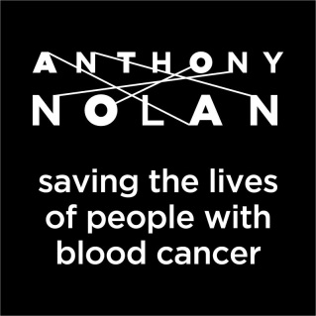

GIVE A SPIT
SAVE A LIFE

Anthony Nolan are looking for your help in their bid to help find a cure for people with blood cancer!
For thousands of people with blood cancers such as leukaemia, their only hope of survival is a donation of blood stem cells. But we can’t just take them from anybody - they have to be from a person who is a match.
YOU COULD BE THAT MATCH
We need more people aged 16-30 to join the register as younger donors provide patients the best chance of life. So, if you’re aged between 16 & 30, weigh over 50kg and in good health you have it in you to save a life!

KNOW THE FACTS
- Joining the register is easy, it just requires some personal info and a small saliva sample
- Donating is simple too – for 90% of people it just involves a process similar to giving blood
- Find out more at www.anthonynolan.org

We would love to come and meet you all at Explorer Scouts and Scout Network to tell you more about our work and perhaps hold an event to get more lifesavers on our register.

If you are interested please get in touch and together we could save more lives…….

amy.bartlett@anthonynolan.org / 07900730757

#bethecure

Registered charity no 803716/SC038827

